Ani Harutyunyan
Diana Manukyan
Julian Amberg
Robby Deffo



Research Paper

California State University, Northridge
BANA650: Healthcare Analysis
12/08/2025



I. Introduction 3
II. Literature Review 3
III. Data and Methods 4
Data Source 4
Database Pipeline 4
Problem: Data Format Inconsistency 4
Solution: Standardized PostgreSQL Database 5
Implementation: ETL Pipeline with Error Handling 5
Data Preprocessing and Cleaning 6
1. CPT Code Extraction and Procedure Filtering 6
2. Treatment Category Construction 7
3. Payer Identification and Group Classification 7
4. Handling Price Variables and Missing Values 8
IV. Results 9
V. Discussion 10
VI. Conclusion 10
VII. References 11
VIII. Appendix 12
A. Database Schema 12
B.1. Implementation: ETL Pipeline with Error Handling 12
B.2. Implementation: ETL Pipeline with Error Handling 13
C. Pre-cleaning Detailed Steps 13
D. Supplementary Figures 14
Figure D1. Negotiated Dollar by City 14
Figure D2. Negotiated Dollar by Treatment Category 14
Figure D3. Median Negotiated Dollar by Treatment Category and Payer Group 15
Figure D4. Negotiated Dollar by Payer Group 16
E. CPT-Stratified Price Variation Analysis 16
Figure E1. CPT-Level Price Variation by City (Robust CV %) 16
Figure E2. Heatmap of CPT Variation by Region (Robust CV %) 17
Figure E3. Scatterplots of Negotiated Prices by CPT Category and City 18
Figure E4. Interactive Map of CPT Stability Across Florida 19
F. Geospatial Analysis Visualizations 20
G. Florida City Demographics 21

Introduction

Price transparency has become a major focus of modern U.S. health policy. In 2021, the Centers for Medicare & Medicaid Services (CMS) enacted regulations requiring hospitals to publicly disclose payer-specific negotiated rates for all billable services in machine-readable files. These data offer an unprecedented opportunity to analyze the structure and causes of health care prices across markets. Although the restrictions were designed to foster competition and promote patient decision-making, early assessments indicate significant variation in the completeness, structure, and quality of released data, making systematic research both problematic and critical.

One of the most complicated and expensive areas of cancer treatment is radiation oncology, which accounts for a sizable portion of treatment costs and puts patients at significant financial risk. Even within the same state, prices for the same Radiation Oncology CPT codes can vary significantly between institutions, payer types, and geographic regions. Such variation raises questions about fairness, reimbursement consistency, and patients' and purchasers' ability to navigate the health system effectively. Despite the increased availability of transparency data, only a few studies have examined how geography and payer mix interact to affect pricing trends in Radiation Oncology services.

Florida is an essential empirical environment for this inquiry, having the 4th largest state GDP and the third-largest state population in the United States (StatsAmerica, 2024). The state offers a rich environment for assessing negotiated rates because of its broad payer landscape, diverse hospital market, and strong commitment to CMS transparency regulations. By leveraging CPT codes 77261–77799 and classifying them into clinically significant Radiation Oncology treatment categories, the current study evaluates the degree to which hospital location and payer group are associated with negotiated price differences.

The research question posed in this study is the following:
Is there a meaningful relationship between hospital location and the negotiated price variation of Radiation Oncology CPT procedures across Medicare, Medicaid, Private/Commercial, and Self-Pay payer groups in Florida?

Policymakers, hospital administrators, insurers, and patients can all benefit from an understanding of how payer-specific and geographic factors affect price dispersion. This work aims to give systematic data on pricing dynamics in radiation oncology and to guide efforts toward improved transparency, fairness, and efficiency in cancer care by reproducing and expanding techniques from recent health economics and informatics literature.

Literature Review
Numerous studies have shown that prices vary significantly between U.S. hospitals, with payer-specific negotiated rates frequently changing multiple times for the same treatments. Private insurers often pay hospitals significantly more than Medicare for the identical services, as Cooper et al. (2019) showed. This is mostly due to market concentration and differences in negotiating power. According to White and Whaley (2020), RAND's employer-led hospital price transparency effort also discovered that commercial charges nationwide averaged 246% of Medicare rates. Research utilizing CMS's new machine-readable hospital files reveals comparably large differences in negotiated pricing between facilities and payers, as well as inconsistent reporting and data format that make cross-hospital comparisons difficult (Bai & Anderson, 2021; Whaley et al., 2023). All of these results show that hospital pricing is still highly variable, payer-dependent, and impacted by local market dynamics even in the presence of mandatory transparency.

Published research in oncology, especially radiation oncology, reveals even more pricing variability. The expenses for traditional IMRT treatments varied by more than 20 times, according to Agarwal et al.'s (2020) analysis of radiation charges among U.S. cancer institutions. Further studies show that payer mix, hospital ownership, and regional competitiveness all significantly impact the negotiated rates for advanced modalities, including SBRT, dosimetry, and treatment planning (Zhu et al., 2021; Smith et al., 2022). Despite this evidence, only a few studies use payer-specific negotiated transparency data to jointly evaluate how geography and payer type contribute to price variance. This disparity highlights the significance of state-level studies, such as this one, that examine radiation oncology costs for Medicare, Medicaid, Private/Commercial, and Self-Pay groups in Florida's competitive, diverse healthcare markets.

Data and Methods

Data Source
This analysis uses publicly available hospital price transparency data published in compliance with the Centers for Medicare & Medicaid Services (CMS) machine-readable file requirements. All Florida hospital pricing files were downloaded from hospitalpricingfiles.org, which aggregates payer-specific negotiated rates reported by hospitals statewide.

There are 246 machine-readable wide-format and tall-format files in the raw dataset (107 tall, 139 wide). Wide-format files feature numerous payer-specific columns per hospital row, whereas tall-format files contain one payer entry per row. Both formats were standardized and imported into a PostgreSQL database via a custom ETL pipeline prior to analysis.

Database Pipeline

Problem: Data Format Inconsistency
The initial data download included 246 hospital price transparency files from hospitalpricingfiles.org. However, these files displayed significant inconsistencies in format. Specifically, 107 files were structured in a tall format (one payer-procedure entry per row), while 139 files utilized a wide format (multiple payer columns per hospital row). This inconsistency needed to be resolved systematically before we could ingest the data into our database.
To assess the extent of the transformation required, we developed a diagnostic script, named tall_vs_wide.py, which scanned all 246 files and classified them by format. The script identified the unique characteristics of each format as follows:
- Tall format: One record per payer-procedure combination, featuring a straightforward row-based structure.
- Wide format: Multiple payer-specific columns within a single hospital row, which necessitated complex restructuring logic.
Understanding these format differences was crucial, as the wide-format files required transformation rules to align with our standardized database schema.

Solution: Standardized PostgreSQL Database
To consolidate all 246 disparate files into a single, queryable environment, we created a PostgreSQL database named `florida_healthcare` with a schema called `pricing`. The primary table, `pricing.charges`, was designed with columns representing all the standardized fields required by CMS transparency regulations.
In our schema design, we decided to define all columns as TEXT. This choice was made due to formatting inconsistencies (e.g., double spacing) and recurring issues encountered when uploading data to our database. Rather than enforcing type conversion, which could risk data loss, we opted to preserve the original values and perform type conversion during downstream analysis. Additionally, the TEXT data type can accommodate any format.
The schema included dedicated columns for codes and code classifications. There are inconsistencies with hospitals reporting billing codes, in some instances having multiple “code” columns and associated "code_type" columns. This was due to hospitals reporting data in the wide format based on payer information. To address this, we created separate columns (1-6) that accounted for all potential “code” and “code | type” fields. Please refer to Appendix A for the relevant columns.
The `natural_key` constraint, which is a concatenation of the hospital identifier, payer, CPT code, and service description, helped prevent duplicate records in the event that the pipeline needed to be re-executed.

Implementation: ETL Pipeline with Error Handling
The actual data transformation and loading were performed by a custom Python ETL pipeline, which performed the following workflow tasks:
Step 1: Connection Management and Security
To prevent data corruption and data leakage, we created a Python virtual environment and stored sensitive information (database host, username, password) in an .env configuration file rather than embedding them in source code. Also, running the validation script (“test_db”) before the main pipeline prevented connection failures from corrupting partial data loads.
Step 2: Format Detection and Transformation
The pipeline processed all 246 CSV files, identified their formats, and applied the appropriate transformations. For the wide-format files specifically, the transformation logic involved unpivoting multiple payer columns into individual rows, each maintaining consistent fields for hospital, payer, and pricing. This approach ensured that all rows, regardless of the source file format, adhered to a uniform table structure.
Step 3: Deduplication and Data Integrity
To address cases in which the pipeline was interrupted and subsequently restarted, we implemented deduplication logic. The script tracked which files had already been processed and skipped exact duplicates using the natural key constraint. This prevented duplicate ingestion without requiring subsequent data deduplication.
Step 4: Data Loading
A total of 246 files were processed by the pipeline, which successfully loaded 1,651,377 records into the “pricing.charges” database. Due to the computational demands of format detection, transformation, and database insertion, the entire pipeline took approximately 48 hours to execute on a standard laptop.
The data transformation and loading were carried out by a custom Python ETL pipeline named (2_wide_to_tall_to_pg.py). This pipeline followed the workflow outlined in Appendix B.1 and B.2.
Step 5: Validation and Database Accessibility
Following pipeline completion, we validated data integrity with a simple SQL query:
SELECT COUNT(*) FROM pricing.charges;
-- Result: 1,651,377 rows successfully ingested
The PostgreSQL database, accessed via DBeaver's graphical interface, enabled us to explore the data structure, execute exploratory SQL queries, and export subsets for downstream analysis without needing direct command-line access.

Data Preprocessing and Cleaning

1. CPT Code Extraction and Procedure Filtering
The study focuses on radiation oncology procedures indicated by CPT codes 77261-77799, which were collected from the unified database using CPT range filters. The procedures included clinical simulation, treatment planning, dosimetry, radiation treatment delivery, stereotactic body radiotherapy (SBRT), brachytherapy, and neutron beam delivery. To ensure statistical reliability, CPT codes were retained only if they appeared in at least 50% of Florida hospitals, decreasing noise and eliminating infrequently used operations. The final analytic dataset has approximately 45 unique CPT codes covering all radiation oncology treatment modalities. (More details concerning the pre-cleaning process are available in the (see Appendix C).

To allow geographical comparisons across Florida markets, a City column was created by scanning hospital address fields and splitting the values at where the city was listed.

2. Treatment Category Construction
Each CPT code was assigned to one of 11 Radiation Oncology treatment categories, allowing studies to be conducted at both the code and category levels. These categories reflect clinically significant groupings (e.g., Clinical Treatment Planning, Brachytherapy, SBRT, Radiation Treatment Delivery) and serve as a framework for later modeling and summary.

3. Payer Identification and Group Classification
Hospital price transparency files frequently contain payer information that is fragmented, inconsistent, or ambiguously reported over numerous fields. In the raw data, payer descriptors appeared in several columns, such as payer_name, plan_name, and additional_payer_notes, with significant variance in formatting, spelling, and specificity between hospitals. To provide a consistent and analytically usable representation of payer identification, these fields were combined into a single normalized text field (payer_text) after lowercasing, trimming, and handling missing values.

A rule-based classification algorithm was created to assign each pricing record to one of four distinct payer categories: Medicare, Medicaid, Self-Pay/Other, or Private/Commercial. Classification proceeded in the following order of precedence to ensure that public program identifiers were captured before commercial plans:

Payer Group | Classification Criteria | Examples of Keywords / Indicators
Medicare | Record contains identifiers associated with traditional Medicare or Medicare Advantage. | “medicare”, “medicare advantage”, “dual complete”, “mapd”, “railroad medicare”
Medicaid | Record contains identifiers for state Medicaid programs or managed Medicaid organizations. | “medicaid”, “medi-cal”, “community plan”, “molina”, “sunshine health”, “amerigroup”, “better health”
Self-Pay / Other | Record contains text-based indicators of uninsured or cash payments or has blank payer fields but includes cash/gross price values. | “self-pay”, “cash”, “uninsured”, “out-of-pocket”; presence of discounted_cash or gross without payer text
Private / Commercial | Default category for all records not matched to Medicare, Medicaid, or Self-Pay based on rules above. | Employer-sponsored plans, individual commercial insurance, and marketplace plans

In addition to keyword-based identification, CMS transparency files use the discounted_cash or gross charge columns to report cash pricing for uninsured patients, even when no payer name is provided. As a result, if payer_text was blank but discounted_cash or gross contained a valid numeric value, the record was classified as Self-Pay/Other, consistent with CMS's reporting guidelines for uninsured or direct-pay pricing.

Records with no payer identifiers or cash price indicators were supposed to be categorized as Unknown, however, there were no such instances.

4. Handling Price Variables and Missing Values
Hospitals usually provide negotiated prices in several different formats - some hospitals report a negotiated dollar amount, others report a negotiated percentage relative to charges, and some provide an estimated amount. Because not all hospitals report all fields consistently, the raw dataset contains incomplete records that cannot be analyzed without systematic handling.
Across the Florida radiation oncology files, the following patterns appeared frequently:
- Some hospitals reported only negotiated_percentage and estimated_amount, but not a negotiated dollar value.
- Others reported a negotiated dollar price directly, with no accompanying estimated amount.
- For certain payer–procedure combinations, hospitals provided gross charges and discounted cash prices, but left negotiated fields empty.
- A smaller subset of rows had partial information, where either the percentage or the estimated amount existed, but not both.
Because our research question relies on comparing negotiated prices across hospitals and payers, a consistent numeric value was required for all observations that were kept in the dataset.
Imputation Logic and Justification
When contracted rates are expressed as a percentage of charges, the negotiated price can be reconstructed using the following formula:
Negotiated Price = Estimated Amount × Negotiated Percentage
Based on this rule, our processing pipeline implemented the following steps:
- When both “estimated_amount” and “negotiated_percentage” were present, we computed a standardized negotiated price using the formula above.
- When only one of the two inputs (estimated_amount or negotiated_percentage) was missing, the row was removed.
- When a valid negotiated dollar amount was already reported, that value was kept, and no imputation was applied.
- Self-pay rows with discounted cash values but no payer text were kept as-is, since the CMS cash price field is considered fully valid and does not require reconstruction.
Why We Avoided Over-Imputation
While multiple imputation or predictive modeling can be used in some research contexts, applying them here would risk introducing bias because:
- Hospitals report negotiated prices using different pricing structures and contract terms.
- Modeled values could artificially reduce genuine variation between hospitals and payer groups.
- The goal of the study is to analyze real-world transparency data, not to smooth it or infer hypothetical pricing.
Outcome of the Missing Value Procedure
After applying these rules, incomplete or non-reconstructible rows were removed, leaving only valid and interpretable negotiated prices. This ensured that the final dataset reflected true reported values and improved comparability across hospitals, payer groups, and treatment categories.
The assembled information contains 67,026 pricing entries for 45 hospitals in 38 Florida towns. Each record includes a CPT code, hospital name, payer information, negotiated price, total charge, cash price, and, if applicable, anticipated amount and negotiated percentage.

Results
City-level boxplots showed that some markets, such as Orlando, Pensacola, Brandon, and Panama City, had much higher negotiated prices compared to smaller cities. When looking across payer groups, the pattern was clear: Medicaid had the lowest negotiated prices, followed by Medicare, then Self-Pay, while Private/Commercial plans showed both the highest prices and the widest variation spread. Comparing treatment categories also revealed that the more complex procedures, such as Neutron Beam Delivery and Stereotactic Radiation Treatment, were far more expensive and varied much more in price than simpler planning or dosimetry services (see Appendix D).
To understand how much prices vary within each CPT category, we ran a CPT-stratified analysis using the Robust CV across 23 cities, the subset of markets with sufficient data and at least three distinct payer groups after cleaning and filtering. The results showed that most of these cities experience very high price volatility, with average variation often exceeding the median by 100–150% for many radiation oncology procedures. Only two cities, Pensacola and Joe, had truly stable pricing (CV < 20%), while larger markets like Orlando, Miami Beach, Tampa, Clearwater, and Port Charlotte showed some of the highest volatility in the dataset. These patterns mirror what we observed in the earlier city- and payer-level analyses and highlight how strongly geographic location influences the consistency of negotiated prices for identical procedures (see Appendix E).
To support these results, we also reviewed geospatial maps to see how pricing varied across different parts of Florida. The maps showed a fairly clear pattern: larger metro areas generally had higher prices and more variation, while many smaller cities showed more stable pricing. These geographic differences match the trends we observed in the statistical analysis and help illustrate how location contributes to price variation. The full set of interactive maps, showing overall price levels, volatility hotspots, CPT-specific trends, payer differences, and data coverage, can be found in Appendix F.

Discussion
To better understand the relationship between the negotiated prices and Florida geographic information, we decided to acquire demographic data from the U.S. Census Bureau (n.d.) (Appendix G). We had compiled by County Subdivision (cities) the information for Income Level, which served as a proxy for purchasing power & negotiating ability, Age, which was a proxy for healthcare usage and potential Medicare prevalence, Insurance Mix (Private, Public, Uninsured) which determines pricing mechanisms & negotiation patterns, and Population Size which helps put into scope the market competition.
We found that basic demographic factors, such as income, population size, or age, do not explain why prices differ between cities. What matters more is the type of insurance people in that city have. Places with more privately insured patients tend to have higher and more unpredictable prices. This is because private insurers negotiate their own deals with hospitals, so prices can vary a lot depending on who has more bargaining power.
In reality, cities with more privately insured patients often tend to be higher-income areas. People in these communities are usually less price-sensitive, which gives hospitals and insurers greater flexibility to set higher rates.
Smaller or lower-income cities, where more people rely on Medicare and Medicaid, tend to have much steadier pricing. Public programs pay fixed rates, so hospitals have less flexibility to charge different amounts. This is why demographics don’t show a strong direct effect, what really matters is the insurance mix that those demographics create.

Conclusion
This study examines the relationship between hospital location and the price variation of Radiation Oncology CPT procedures in Florida. While location has a statistically significant effect on prices (Kruskal-Wallis H = 6750.92, p < 0.001), payer type is the dominant factor influencing price variation. The analysis reveals that private/commercial payers experience a coefficient of variation of 756.3% with a mean price of $3,010.57, while self-pay/other patients see a 329.1% CV with a mean of $1,948.31. Medicaid shows a 227.8% CV with a mean price of $906.44, and Medicare reflects a 149.3% CV with a mean of $1,231.20. This underscores that negotiating power, particularly from private insurers, heavily influences pricing, leading to significant disparities for complex procedures. Moreover, price variations across cities range from 30.6% to 1,133.8%, primarily reflecting the payer market mix rather than geographic factors. It is noted that larger metropolitan areas tend to have higher pricing due to a stronger presence of private insurance. Lastly, there are no significant demographic effects influencing the price variation observed in the study.

References
Agarwal, A., Day, C. N., Chen, R. C., & Royce, T. J. (2020). Assessment of radiotherapy costs across U.S. cancer centers. JAMA Oncology, 6(3), 477–479. https://doi.org/10.1001/jamaoncol.2019.6126
American Academy of Professional Coders (AAPC). (n.d.). CPT® code range 77261–77799: Radiation oncology treatment. https://www.aapc.com/codes/cpt-codes-range/77261-77799/
Bai, G., & Anderson, G. F. (2021). Variation in the availability and quality of hospital price data. JAMA Internal Medicine, 181(8), 1120–1129. https://doi.org/10.1001/jamainternmed.2021.2491
Centers for Medicare & Medicaid Services (CMS). (n.d.). Hospital price transparency [GitHub repository]. GitHub. https://github.com/CMSgov/hospital-price-transparency
Cooper, Z., Craig, S., Gaynor, M., & Van Reenen, J. (2019). The price ain’t right? Hospital prices and health spending on the privately insured. The Quarterly Journal of Economics, 134(1), 51–107. https://doi.org/10.1093/qje/qjy020
Patient Rights Advocate. (n.d.). Easy access to all hospital price transparency files: Hospital price transparency machine-readable files. https://hospitalpricingfiles.org/
Smith, B. D., Lee, C., Nguyen, T., & Das, S. K. (2022). Drivers of variation in radiation oncology pricing across U.S. hospitals. Journal of Oncology Practice, 18(4), 221–230. https://doi.org/10.1200/OP.21.00555
StatsAmerica. (n.d.). Florida rankings: State population and gross state product. https://www.statsamerica.org/sip/Economy.aspx?page=gsp&ct=S12
U.S. Census Bureau. (n.d.). Explore Census Data: Florida city-level demographic tables. https://data.census.gov/
Whaley, C. M., Brown, T., Robinson, J., & Ody, C. (2023). Transparency in Coverage data and variation in prices for common health care services. JAMA Health Forum, 4(10), e233663. https://doi.org/10.1001/jamahealthforum.2023.3663
White, C., & Whaley, C. M. (2020). Prices paid to hospitals by private health plans: Findings from Round 3 of an employer-led transparency initiative. RAND Corporation. https://www.rand.org/pubs/research_reports/RR4394.html
Zhu, J., Kapadia, N. S., Efstathiou, J. A., & Smith, B. D. (2021). Price variation for radiation therapy across hospital markets. International Journal of Radiation Oncology, Biology, Physics, 110(2), 456–464. https://doi.org/10.1016/j.ijrobp.2021.01.043

Appendix

A. Database Schema
Schema snippet (relevant columns):
sql
CREATE TABLE pricing.charges (
"hospital_name" TEXT,
"payer_name" TEXT,
"negotiated_dollar" TEXT,
"negotiated_percentage" TEXT,
"estimated_amount" TEXT,
"code | 1" TEXT,
"code | 1 | type" TEXT,
"code | 2" TEXT,
"code | 2 | type" TEXT,
-- ... additional code columns ...
"natural_key" TEXT,
UNIQUE ("natural_key")
);

B.1. Implementation: ETL Pipeline with Error Handling
Connection verification was performed using a separate test python script:
# test_db.py - Verify PostgreSQL connection before running main pipeline
import psycopg2
from dotenv import load_dotenv

load_dotenv()
conn = psycopg2.connect(
host=os.getenv("DB_HOST"),
user=os.getenv("DB_USER"),
password=os.getenv("DB_PASSWORD"),
database=os.getenv("DB_NAME")
)
print("✓ Database connection successful")
conn.close()
Running this validation script before the main pipeline prevented connection failures from corrupting partial data loads.

B.2. Implementation: ETL Pipeline with Error Handling
Detecting format and applying appropriate transformation via the following python code:
python
# Simplified logic from 2_wide_to_tall_to_pg.py
for csv_file in hospital_files:
df = pd.read_csv(csv_file)

# Detect format
if is_wide_format(df):
df = transform_wide_to_tall(df) # Apply reshape logic

# Standardize to database schema
df_normalized = normalize_columns(df)

# Load to database
df_normalized.to_sql('charges', con=engine, if_exists='append')

C. Pre-cleaning Detailed Steps
- Data from the database has unique ID values, but is not formatted correctly and is not usable for the 1 million + observations
- The database CSV file "charges_radiology.csv" is used, and a new column for [“unique_id”] is created
  - ID created provides a unique identifier for each row (starts with prefix A and follows the count of the row)
- Consolidation of all codes and code types into individual columns, as well as keeping only the CPT codes
  - There is a CPT code for each row, so filtering does not remove rows
- Using “NEWID_charges_radiology.csv”, the code pairs the three columns together ([“unique_id”], [“type”], and [“code”]) and filters for code types == “CPT”
- Merges “NEWID_charges_radiology.csv” and “cpt_only_by_id.csv” on the column [“unique_id”]
- The count of unique hospitals within the Radiation Oncology CPT code range is counted, and the CPT code procedures that were found within 50% or more of the unique hospitals are selected. The Pre-processing code shows each CPT code and counts the instances it appears in a unique hospital. This applies to all codes found in the file and provides the unique count of hospitals:
  - 37 unique hospitals
  - 37*50% = 18.5 --> 19 minimum
- From here, the file has been filtered only to include codes within the range of Radiation Oncology (77261-77799) and only to show values equal to or above 19 (also to be ordered from least to greatest)
- The CPT codes that are displayed are the codes to be used
  - Unique hospital count lowered to 34
- We need to filter the CSV one more time, only to include the CPT codes that are present in 50% or more of the unique hospitals within the Radiation Oncology range
- The code takes the CPT code range (hardcoded) and filters the code column to only include codes within the range
- Exports to new Excel “filtered_cpt_codes.xlsx”

D. Supplementary Figures
This appendix provides the visual analyses referenced throughout the Results and Discussion sections. These figures illustrate negotiated price variation across Florida cities, payer groups, and radiation oncology treatment categories.

Figure D1. Negotiated Dollar by City
This figure shows how negotiated prices vary across 31 Florida cities with at least 200 observations. Cities such as Orlando, Pensacola, Brandon, and Panama City exhibit higher median prices and greater variability, while other cities remain more tightly clustered.

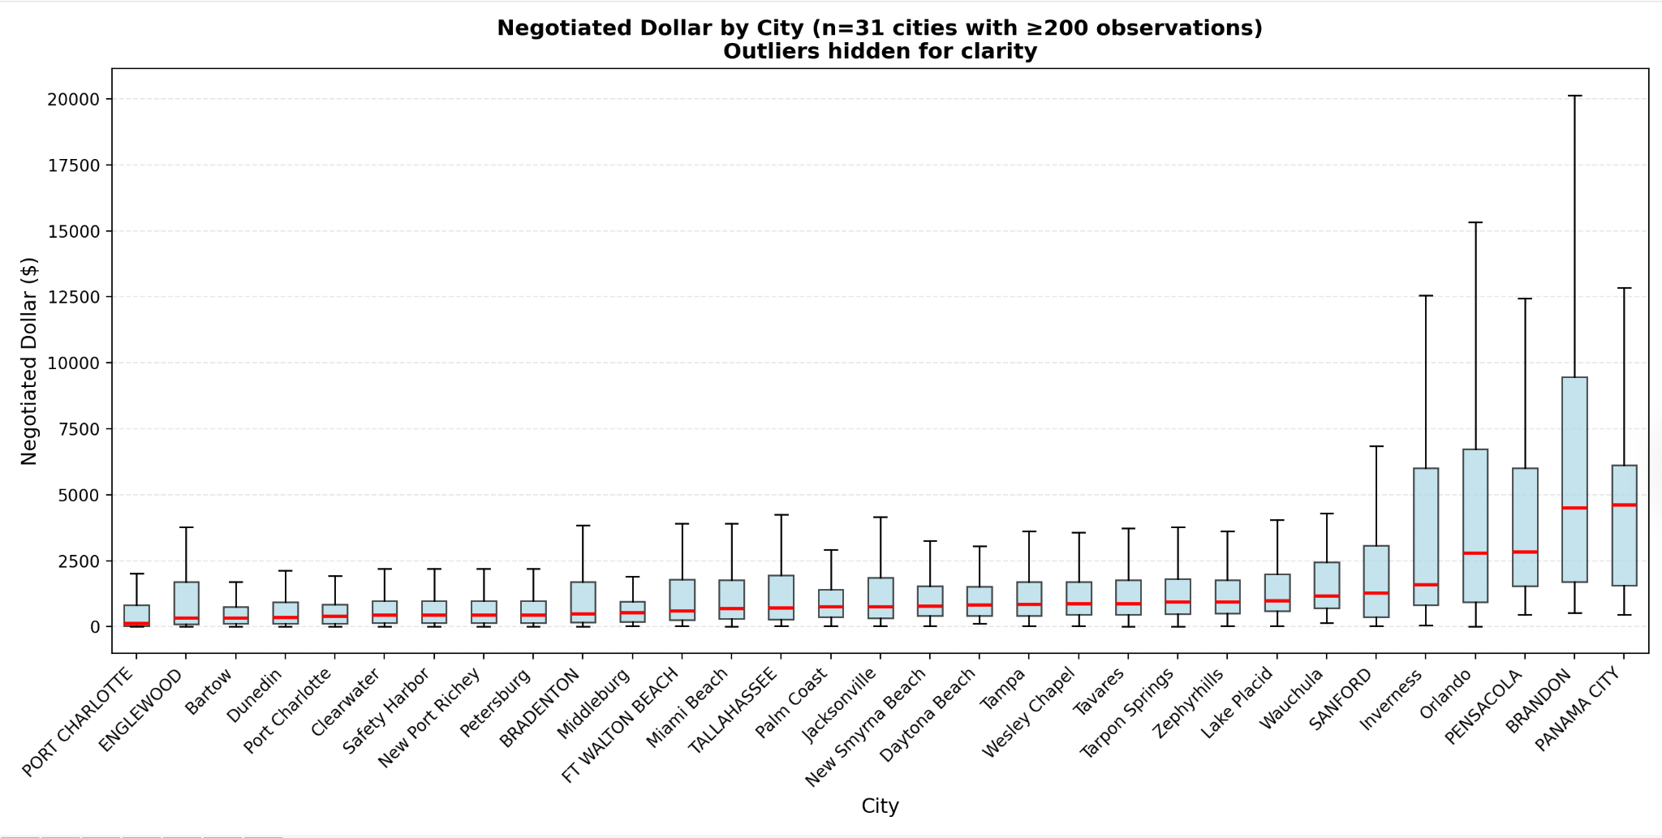
Figure D1

Figure D2. Negotiated Dollar by Treatment Category

This visualization displays price dispersion across radiation oncology treatment categories. More complex modalities, such as Neutron Beam Delivery and Stereotactic Radiation Treatment Delivery show significantly higher negotiated prices than planning or dosimetry services.
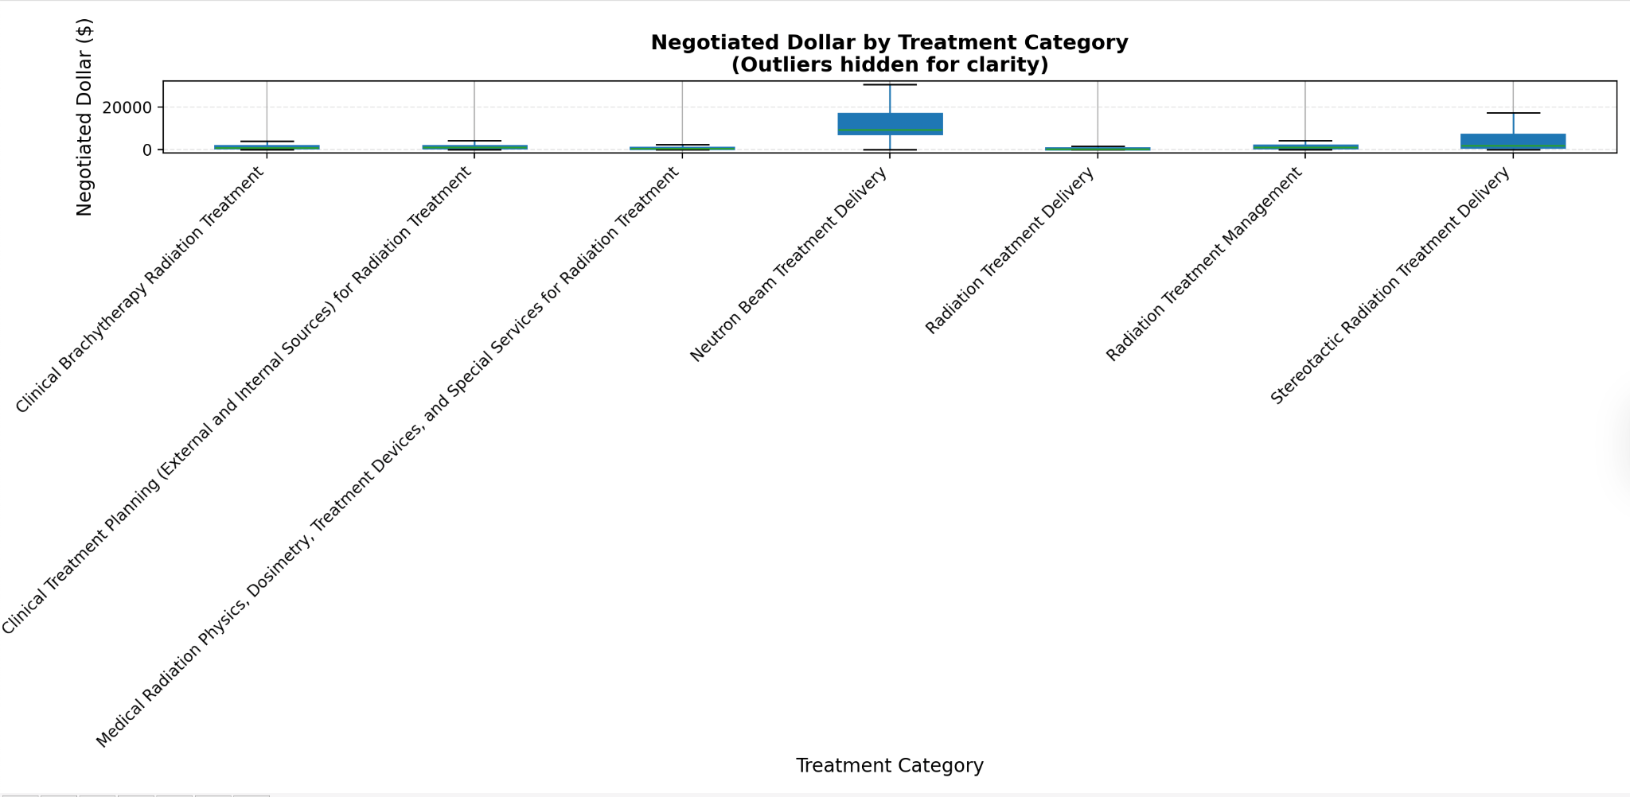
Figure D2

Figure D3. Median Negotiated Dollar by Treatment Category and Payer Group

The heatmap compares median negotiated prices across payer groups. Private/Commercial and Self-Pay often show the highest median prices, while Medicaid consistently reports the lowest across nearly all treatment categories.
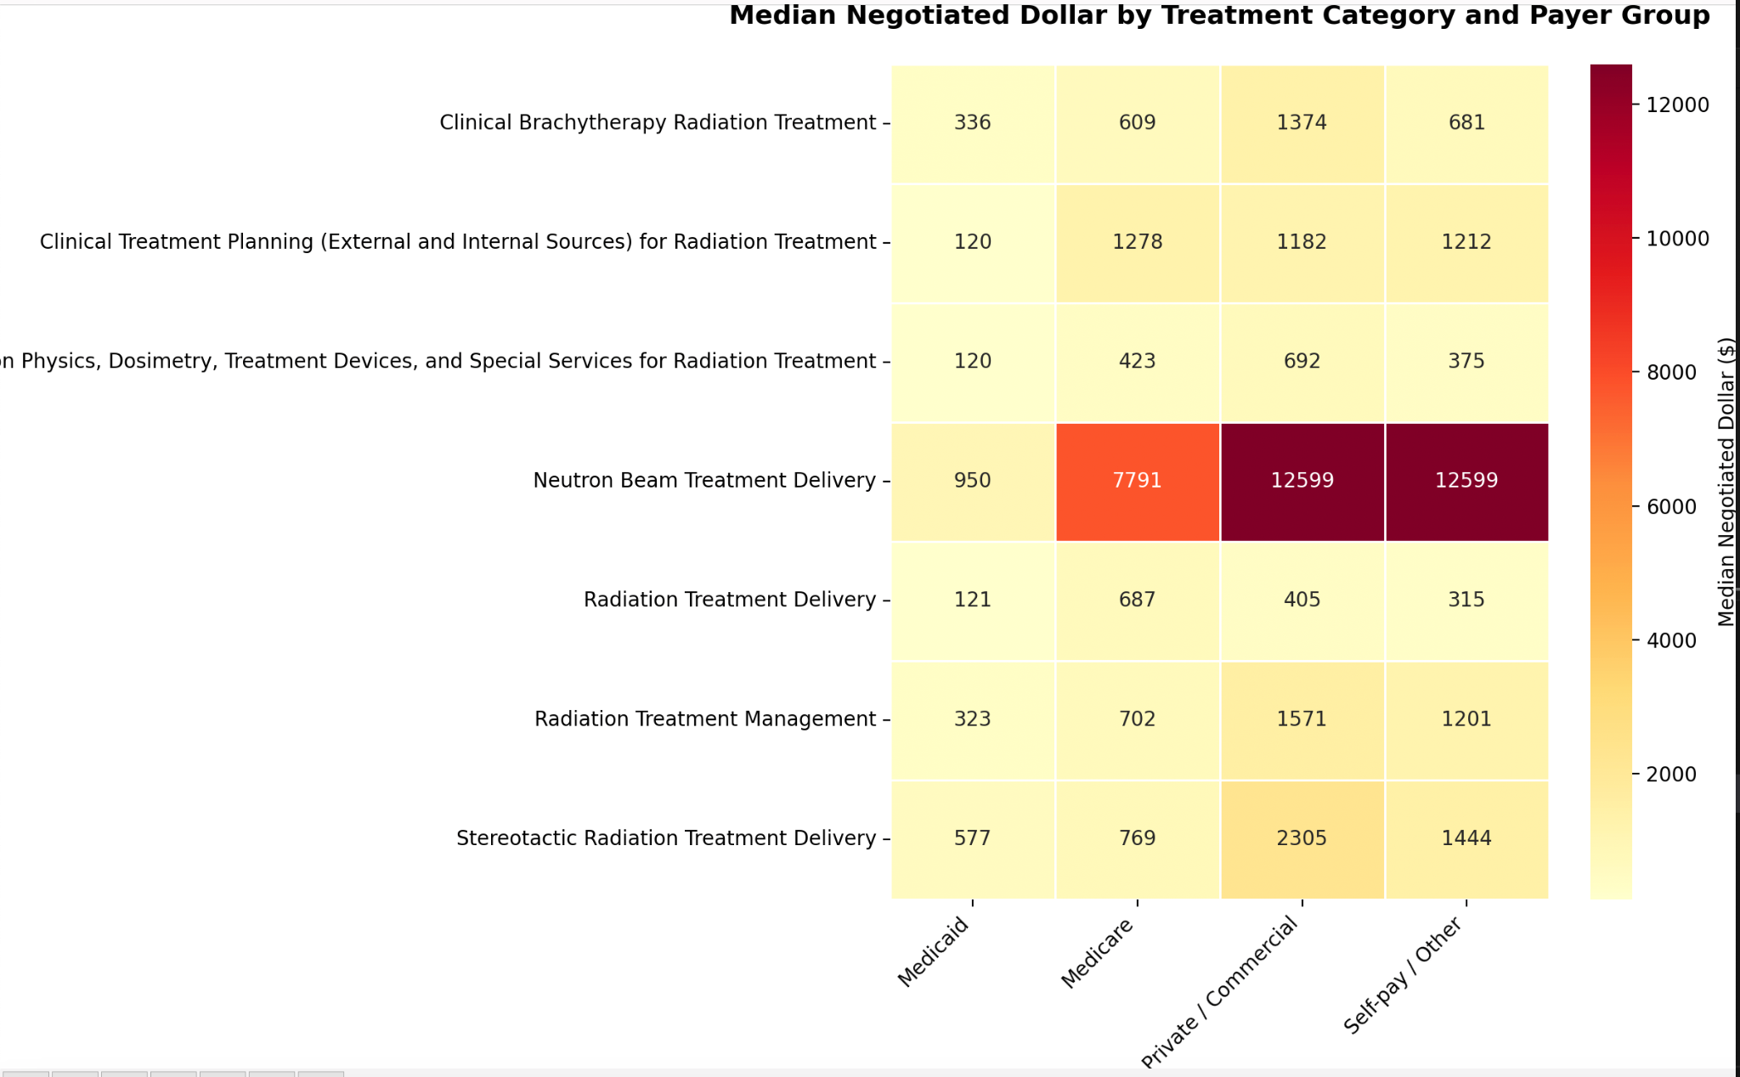
Figure D3

Figure D4. Negotiated Dollar by Payer Group

This boxplot highlights substantial variation between payer groups. Private/Commercial rates show the widest spread and highest medians, while Medicaid prices remain the lowest and most compressed.
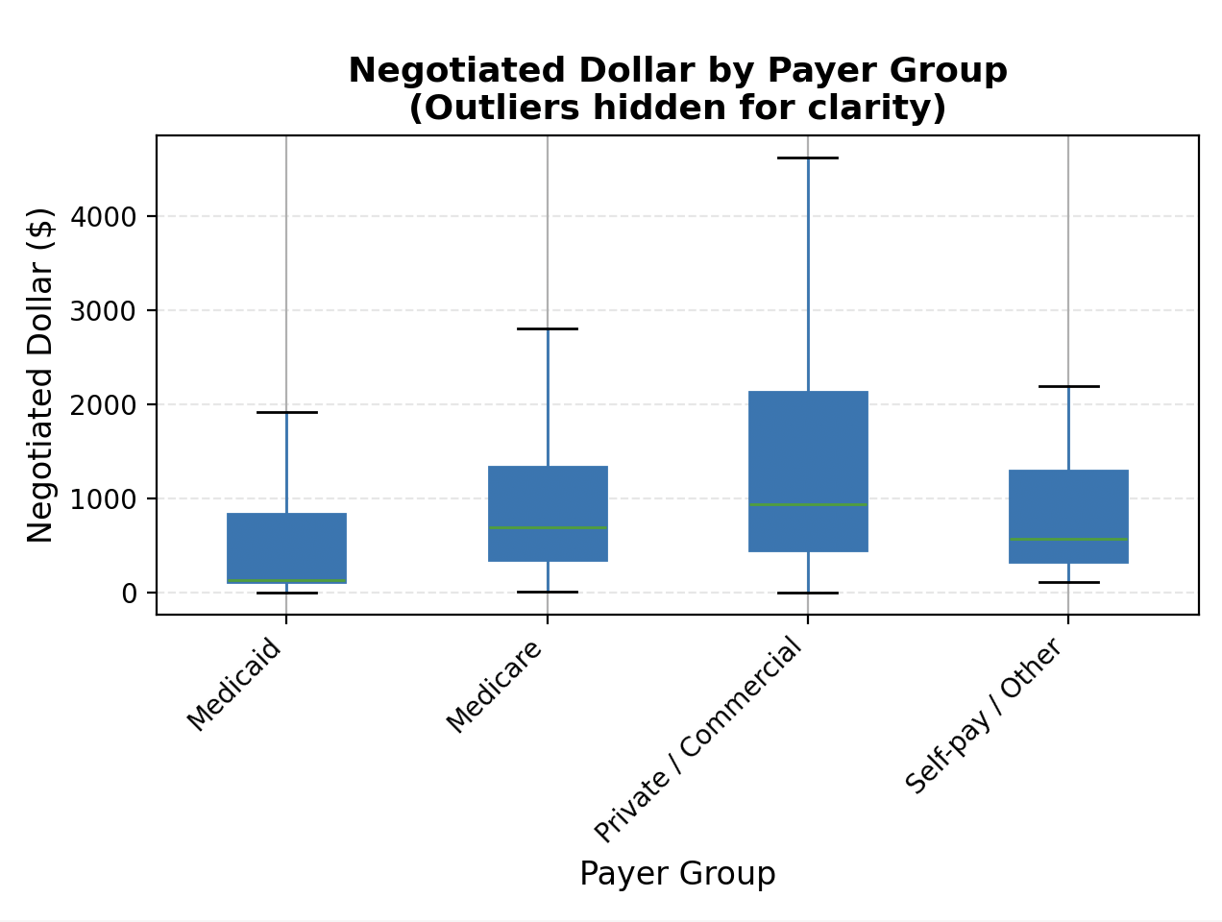
Figure D4

E. CPT-Stratified Price Variation Analysis

These figures illustrate how negotiated price variation differs within Radiation Oncology CPT categories and across Florida cities, highlighting patterns that are not visible in city-level or payer-level summaries alone.

Figure E1. CPT-Level Price Variation by City (Robust CV %)

These charts present the Robust Coefficient of Variation (Robust CV %) for each treatment category within individual cities.
Only a few cities, such as Jacksonville and Joe, show moments of stable pricing for specific procedures, while others like Bartow, Clearwater, and Dunedin display only moderate stability in isolated CPT categories. The biggest swings tend to appear in the more complex treatments, like Stereotactic therapy and Radiation Treatment Management, where prices differ widely across providers.
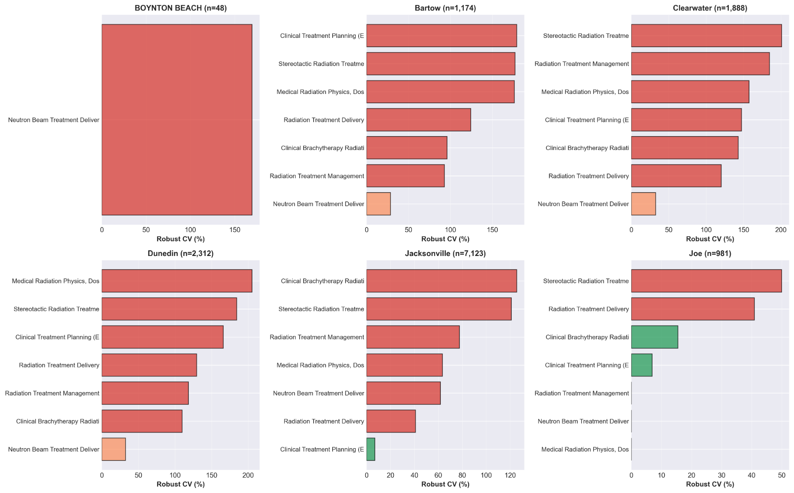
Figure E1

Figure E2. Heatmap of CPT Variation by Region (Robust CV %)

This chart shows that in most cities, hospitals charge very different prices for the same radiation oncology procedure, which is why so many cells are red. Only a few cities and CPT codes show any real consistency (the green cells), highlighting that stable pricing is rare and varies a lot from city to city across Florida.
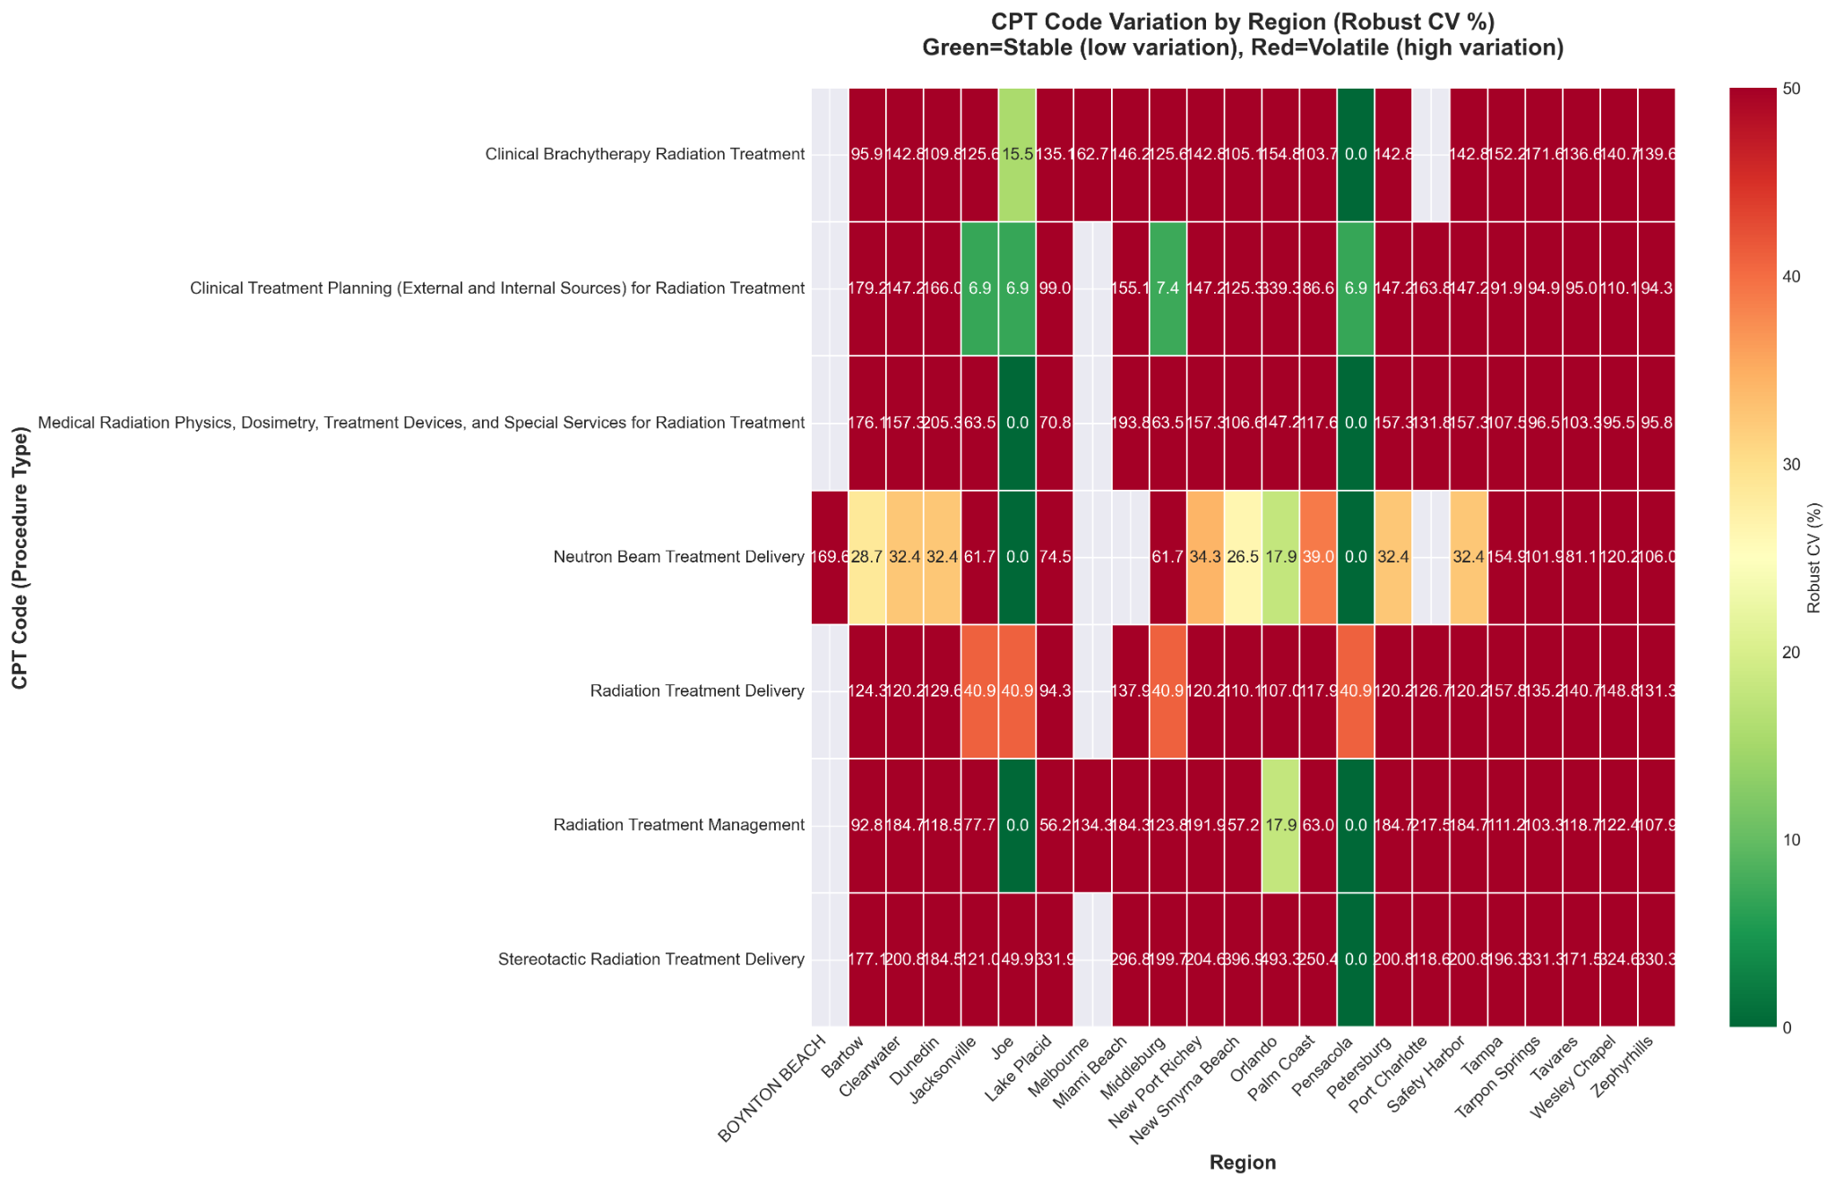
Figure E2

Figure E3. Scatterplots of Negotiated Prices by CPT Category and City

The scatterplots show the actual prices hospitals negotiated for each CPT category, and some procedures have outliers that shoot up to $250,000 - $1,000,000. Even the more routine treatments vary a lot from hospital to hospital - some cities stay clustered at lower prices, while others have dramatic spikes, which lines up with what we saw in the CV results.

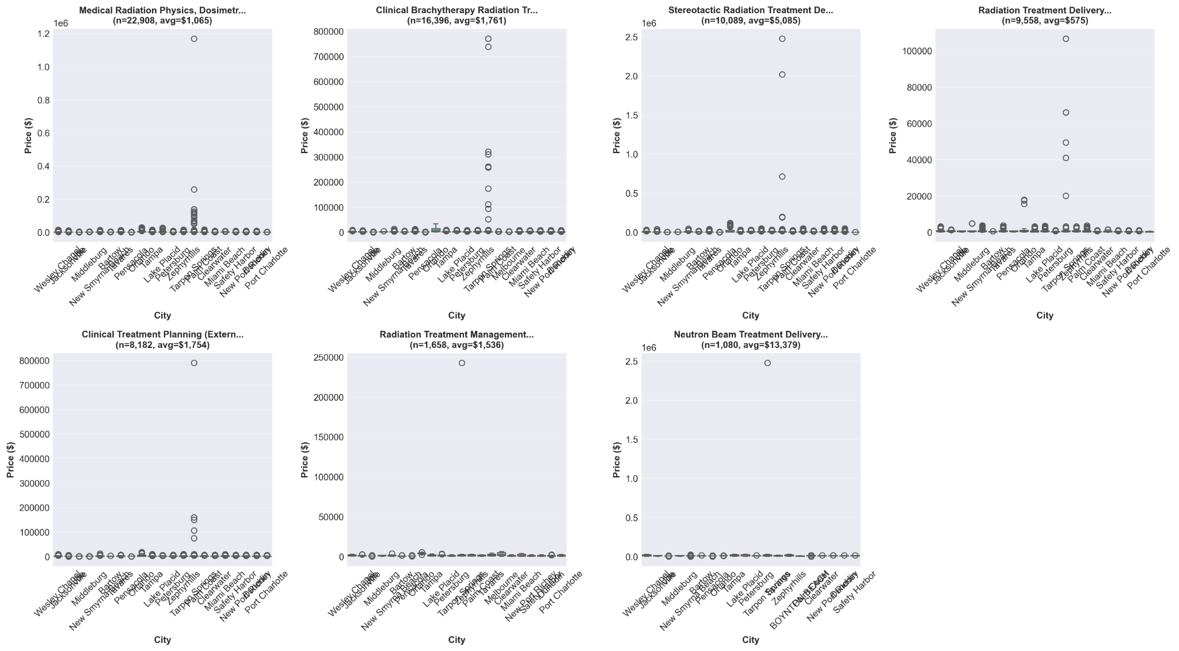
Figure E3

Figure E4. Interactive Map of CPT Stability Across Florida

This map shows how stable or unstable each city’s pricing is by averaging the Robust CV across all CPT categories, with larger circles indicating more data. The cities on the map are shaded red, meaning every location is classified as volatile (CV > 35%). No cities appear in the moderate (orange) or stable (green) categories, suggesting that pricing instability is widespread across Florida.

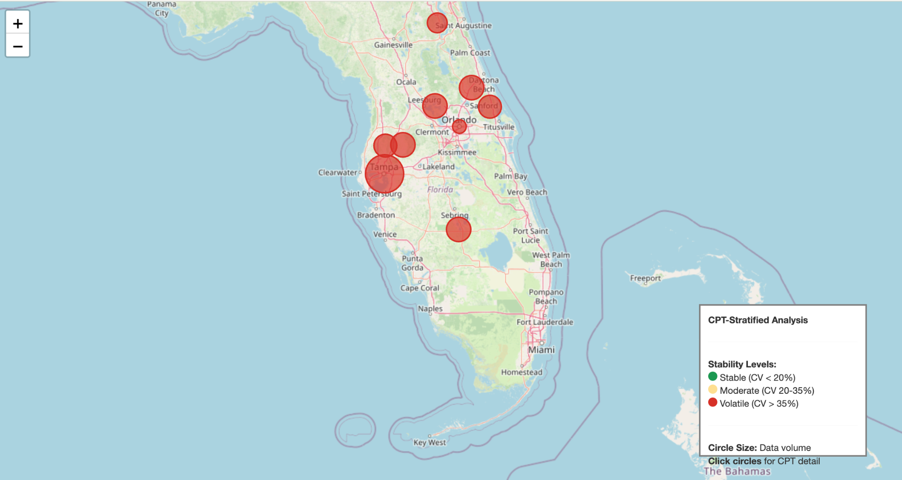
Figure E4

F. Geospatial Analysis Visualizations
This appendix includes all of the interactive geospatial maps produced from the 6_geospatial_visual.py script. These maps help visualize how radiation oncology prices differ across Florida, adding a geographic layer to the statistical findings in the report. They show overall price patterns, areas with high volatility, payer differences, CPT-specific pricing, and how much data each city contributes. Because these maps are fully interactive, they are provided as external HTML files in the project submission under RESULTS/geospatial rather than as static figures. Please open them in any web browser to explore the geographic pricing patterns.

01_Map_Overall_Price_Landscape.html
This map gives a big-picture view of how average negotiated prices look across Florida. Each city shows up as a bubble, where the size reflects how much data we have and the color indicates how expensive that area tends to be. It’s an easy way to spot which regions generally have higher or lower prices.

02_Map_Price_Variation_Hotspots.html
Here, the focus is on volatility. The map highlights cities where prices for the same procedure swing wildly between hospitals. Darker colors point to places with the most inconsistent pricing, helping us see which markets are the most unpredictable.

03_Map_CPT_01_Medical_Radiation_Physics.html
This map zooms in on services related to medical radiation physics, treatment devices and dosimetry. It shows where these foundational planning services are priced higher or lower across the state, giving a sense of how much variation exists even in the early stages of treatment.

03_Map_CPT_02_Clinical_Brachytherapy.html
This one focuses on Brachytherapy. Since this treatment can require specialized expertise and equipment, the map helps show which cities price it unusually high or low compared to others.

03_Map_CPT_03_Stereotactic_Radiation_Treatment.html
Stereotactic procedures are some of the most expensive in radiation oncology. This map makes it clear where those high prices are concentrated and which cities stand out for having especially large differences.

03_Map_CPT_04_Radiation_Treatment_Delivery.html
This map looks at one of the most common services: treatment delivery. Because it’s done so often, differences in cost here matter a lot. The visualization helps compare everyday pricing across cities.
03_Map_CPT_05_Clinical_Treatment_Planning.html
This shows how much hospitals charge for treatment planning. Since the planning process is usually more standardized, seeing price differences across cities helps identify where pricing might be inflated or unusually low.

03_Map_CPT_06_Radiation_Treatment_Management.html
Here we map out treatment management costs, these are the ongoing charges as patients go through their care. The map highlights which cities tend to have higher ongoing management fees versus more moderate ones.

04_Map_Payer_Disparities.html
This map compares how different payer groups (Medicaid, Medicare, Private plans, Self-Pay) are charged across cities. It helps show where payer-based differences are especially large and where pricing is more uniform.

05_Map_Data_Coverage.html
Finally, this map shows where our data is strongest. Larger bubbles mean more CPT entries were reported from that city. This helps put the rest of the findings in context by showing which cities contributed the most reliable amount of data.

G. Florida City Demographics
- The Florida City demographics data is acquired through the census database using the following fields:
  - City names (labeled County Subdivision)
  - Population
  - Health Insurance Coverage
  - Household Income
- A CSV was constructed using the following American Community Surveys to compile the data:
  - ACSDP5Y2023.DP05-Data_DP05ACS - Demographic and Housing Estimates
  - ACSDT5Y2023.B27015-Data_B27015 - Health Insurance Coverage Status and Type by Household Income in the Past 12 Months (in 2023 Inflation-Adjusted Dollars)

